Third party Capture

Independent research commissioned by the Association of British Insurers has shown that people who deal directly with the other side’s insurer receive fair compensation faster when compared with those with legal representation.

*(See http://www.abi.org.uk/Publications/ABI_Publications_Outcomes_for_legally_represented_and_ unrepresented_claimants_in_personal_injury_compensation_fc1.aspx,* ***2010****)*

For example, as much as 10% of motor premiums are spent on legal costs alone.

*(See 2007 ABI/IUA Fourth UK Bodily Injury Awards Study, pg 10,* ***2007****)*

Are there situations where it is better to have legal advice? While insurers wish to have this process open to most people, insurers will strongly recommend that independent legal advice is sought in certain situations, for example:

* If the injured person is under 18 years old.
* Where there is complexity over who was at fault for the accident.
* If you have a limited understanding of English.
* Where the injury involved requires more than one medical report or has a degree of complication, persistence or permanence.

*(<https://www.abi.org.uk/globalassets/sitecore/files/documents/publications/public/migrated/motor/third-party-assistance-claimant-guide.pdf>,* ***2010****)*

Real Time Claim Processing and Insurance Analytics. - Identifying levers to pull like; Claim Analytics involve insights of Claim Processing. Track Real-Time Claim Processing to improve customer satisfaction. Claim Scoring improves assignment and management of claims. Claim Data Processing promotes loss recovery, shortening of the claim cycle. Implementation of analytics to claim cycle yields in Return On Investment (ROI) with cost savings. Insurance Analytics Real-Time Applications

* Risk Assessment
* Automation
* Smarter Finance
* Customer- Centric
* IoT implementation
* Real-Time Trigger Based Analytics
* Hidden Revenue Opportunities

*(<https://www.xenonstack.com/use-cases/insurance-analytics-fraud-detection-ai/download/>)*

MOTOR RECOVERY

IN PRACTICE: Predictive model for recovery helps insurance carrier save $3mm.

For a global insurance carrier, Capgemini helped apply predictive analysis to help minimize the claims sent to subrogation. The claims were evaluated as follows:

1. Not all recovery claims are sent to subrogation.
2. Not all claims sent to subrogation are recovered.
3. Some claims sent to subrogation are not relevant for recovery n Actual status of referred claim may be unknown.

This may lead to less accurate models and false positives like claim appears to be subrogation but is not and false negatives like subrogation claim is not detected because this is an unknown pattern.

The Results n For automotive and workers comp, the insurance carrier can now identify and prioritize high quality recovery opportunities. The carrier achieved a 50% lift rate in quality referrals for workers comp and a 12% lift rate for automotive. Overall, the carrier projected $3mm in cost savings annually.

*(<https://www.capgemini.com/wp-content/uploads/2017/07/Claims_Analytics_for_Insurance.pdf>,* ***2017****)*

Repairer assignment

* Repair costs are rising, reflecting ever more sophisticated vehicle design and technology, which in most cases costs more to repair when damaged. Current figures show that the repair bill for insurers in the first quarter of this year was £1.2 billion, the highest quarterly figure since the ABI started collecting this data back in 2013.
* In the first three months of this year, the cost of theft payouts rose 22% to £108 million on the same period last year. The rise reflects Home Office figures recording a 50% rise in vehicle thefts over the last five years. The increase is in part being driven by keyless car crime.

*(<https://www.abi.org.uk/news/news-articles/2019/07/fall-in-the-cost-of-motor-insurance-stalls-as-the-abi-warns-of-a-bumpy-road-ahead-for-motorists/>,* ***2019****)*

Today’s figures show that:

* the average price paid for motor insurance in the third quarter of the year, at £468, fell marginally by £1 on the second quarter;
* the average premium paid fell by £3 on the same quarter last year.

*(*<https://www.abi.org.uk/news/news-articles/2019/10/competition-is-keeping-the-cost-of-motor-insurance-flatbut-for-how-much-longer/>*,* ***2019****)*

MOTOR INSURANCE

The United Kingdom (UK) motor insurance sector accounts for a considerable share of the European market. Furthermore, it also is a large part of the property and casualty insurance business in the country.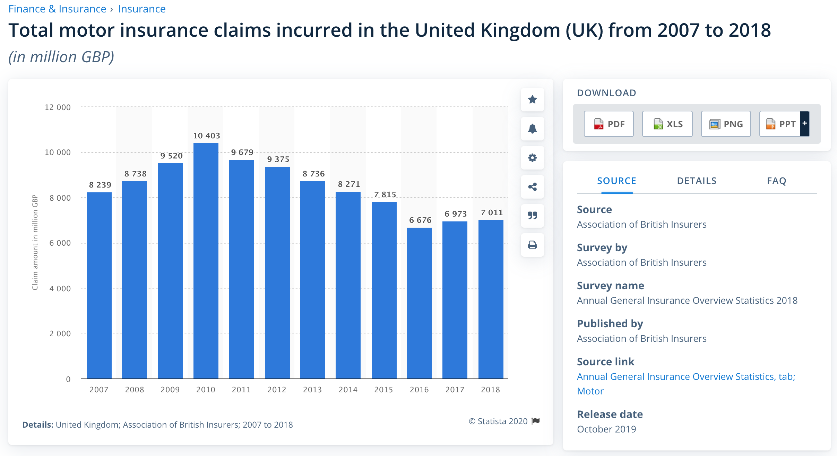

**Motor insurance claims in the UK**

In 2018, there was a total of over seven billion British pounds of motor insurance claims incurred in the UK, with the largest number of claims recorded in 2010 at more than 10.4 billion British pounds. For comparison, in 2018, insurance companies recorded over 20.7 billion euros in gross written motor insurance premiums on the domestic market.

**Fraudulent claims**

How high the pay out of a claim is depends on the severity of the damage or injury. In 2018, the average claim for bodily injury was 10.5 thousand British pounds. Not all claims are legitimate and paid out. In 2018, approximately 54 thousand claimsworth 628 million British pounds were detected as fraudulent.

(<https://www.statista.com/statistics/297435/uk-insurance-market-total-motor-insurance-claims-incurred/>*,* ***2020***)

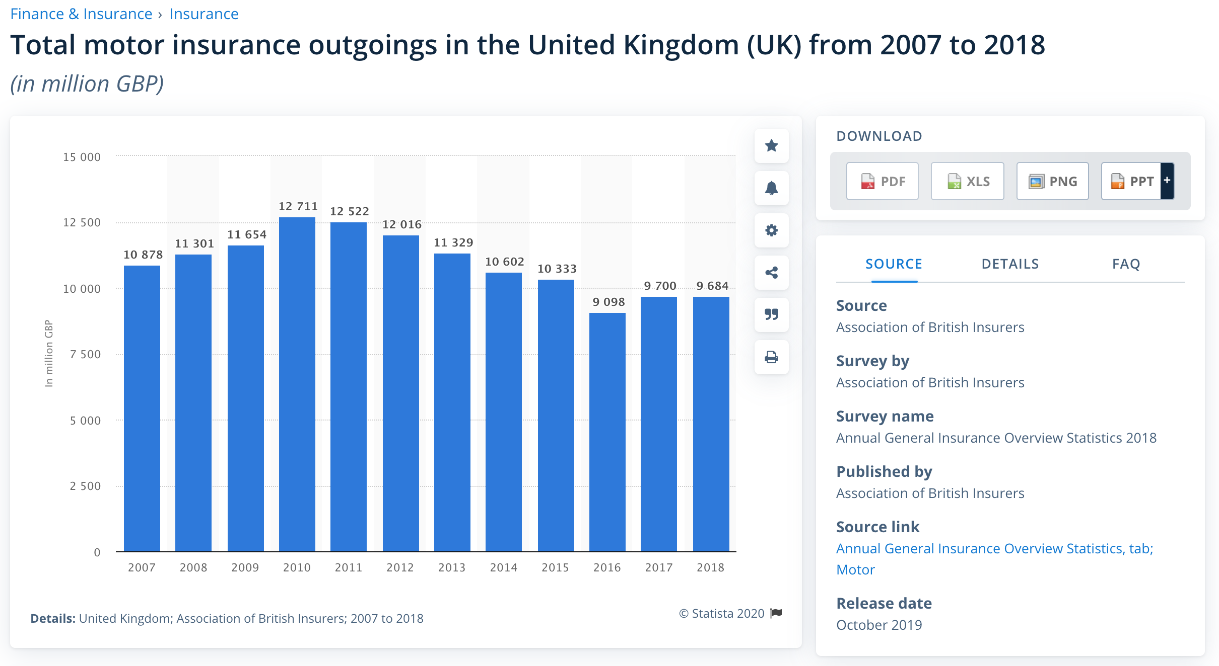

This statistic shows the total motor insurance expenses of the general business insurance market in the United Kingdom (UK) from 2007 to 2018. Between 2007 and 2018 motor insurance outgoings fluctuated. In 2018, the total motor insurance expenses amounted to nearly 9.7 billion British pounds (GBP). 2010 saw the highest value of motor insurance expenses amounting to over 12.7 billion British pounds.

(<https://www.statista.com/statistics/297429/uk-insurance-market-total-motor-insurance-expenses/>*,* ***2020***)

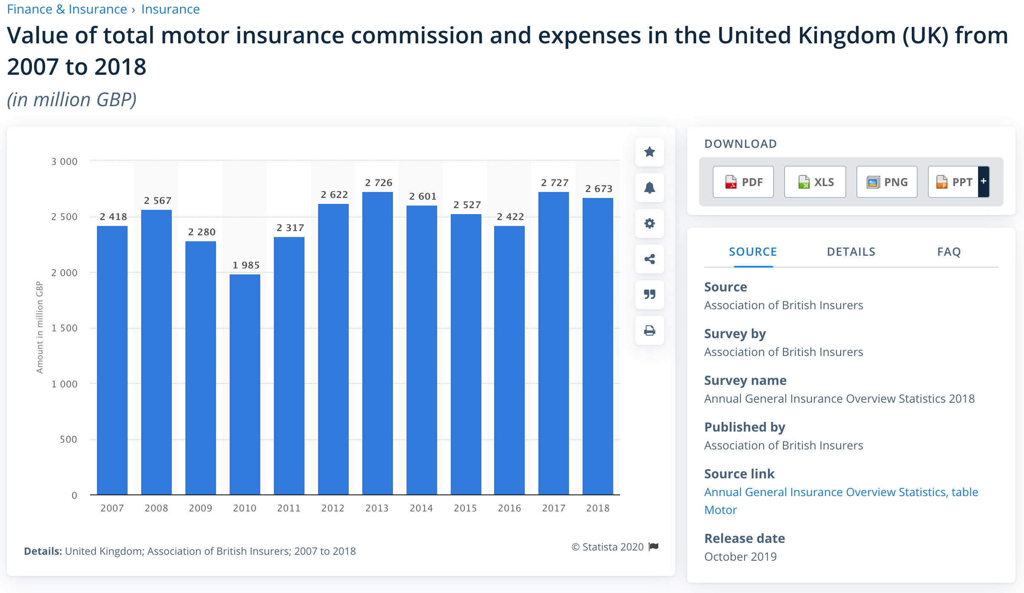

This time series shows the value of motor insurance commission and expenses of the general business insurance market in the United Kingdom (UK) from 2007 to 2018. In 2018, the value of motor insurance commission and expenses amounted to nearly 2.7 billion British pounds (GBP).

(<https://www.statista.com/statistics/297441/uk-insurance-market-total-motor-insurance-commission-and-expenses/>, ***2020***)

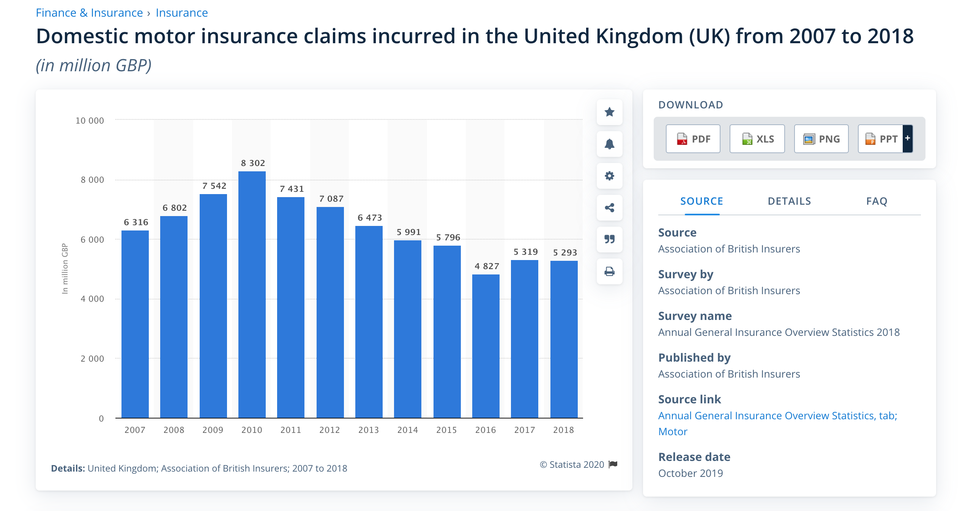

This timeline gives an overview of the domestic motor insurance claims incurred in the United Kingdom (UK) from 2007 to 2018. In 2018, the domestic motor insurance claims incurred amounted to almost 5.3 billion British pounds (GBP). Domestic claims incurred made up the majority of total claims for motor insurance in the United Kingdom.

*(*<https://www.statista.com/statistics/297436/uk-insurance-market-domestic-motor-insurance-claims-incurred/>*, ,* ***2020***)

Important key figures

MOTOR INSURANCE PREMIUMS

* Motor insurance: Gross written premiums UK 2018 - 20.72bn EUR
* Avarage motor insurance premium UK - 475 GBP
* Average weekly household expenditure on vehicle insurance UK - 11.3 GBP

MOTOR INSURANCE CLAIMS

* Total motor insurance claims 2018 - 7bn GBP  
  Total domestic motor insurance claims 2018 - 5.3bn GBP
* Personal lines motor insurance claims paid per day 2018 - 22m GBP
* Commercial motor insurance claims paid per day 2018 - 7m GBP
* Average motor insurance private car claim - 3082 GBP
* Average motor insurance bodily injury claim - 10.45k GBP

INSURTECH AND MOTOR INSURANE

* Usage based insurance (UBI) penetration in the UK - 3%
* Usage based insurance (UBI) policies growth rate UK - 32.5%
* Share of people (45-54) who bought motor insurance online UK - 61.2%

*(*<https://www.statista.com/topics/4560/car-insurance-in-the-uk/#dossierSummary__chapter3>*,* ***2020****)*

OTHER LINKS

1. *<https://www.gov.uk/cma-cases/private-motor-insurance-market-investigation#analysis>*
2. ***Important:*** *<https://assets.publishing.service.gov.uk/media/5421c2ade5274a1314000001/Final_report.pdf>,* ***2014***
3. *<https://assets.publishing.service.gov.uk/media/5329dee040f0b60a7300027b/130816_not_at_fault_survey_tables.pdf>*
4. *<https://www.sas.com/en_in/insights/articles/risk-fraud/big-data-analytics-improves-claims-processing.html>*

PERSONAL INJURY

*(<https://www.aviva.com/content/dam/aviva-corporate/documents/newsroom/pdfs/reports/aviva-UK-claims-report-2017.pdf>,* ***2017****)*

* Personal injury costs are one of the biggest costs in motor insurance, contributing 28% on average.
* Claims are rising - Latest data shows that since 2005 motor personal injury claims are around 40% higher while road accidents have fallen by nearly 35%.
* Cold calling claims cowboys are driving up costs -in the year from April 2017 there were 630 personal injury claims management companies in the UK, turning over £157 million a year. The Claims Management Regulator cancelled 45 licences and issued 252 warnings to Claims Management Companies, reflecting some of the poor practice in the sector.
* We are an international outlier when it comes to the calculation of long-term personal injury awards - At minus 0.75% we have a personal injury Discount Rate that is the lowest (and therefore the most costly) of any major economy in the world. Whiplash style claims are much more common in the UK than in other major economies.
* The average motor premium paid rose by 9% in 2017 to a record high, adding an extra £40 to the average motor insurance policy.
* Insurers have a good track record of passing on cost savings - The industry passed on savings under reforms introduced in the Legal Aid, Sentencing and Punishment of Offenders Act 2012 (LASPO), which saw premiums fall by £50 on average over the next two years.

*(<https://www.abi.org.uk/products-and-issues/topics-and-issues/personal-injury-claims/>,* ***2019****)*

Simplify the claims system so legal advice is only paid for on road traffic personal injury claims over £5,000 (rather than £1,000). - Highlights importance of predetermining claim value in PI.

*(<https://www.abi.org.uk/products-and-issues/topics-and-issues/personal-injury-claims/>,* ***2019****)*

* April 2020 reforms about to hit the sector
* The response of PI firms to the April 2020 changes
* PI claims after Brexit
* Market forecasts
* Personal injury practitioner survey

*(<https://www.businesswire.com/news/home/20191018005391/en/United-Kingdom-Personal-Injury-Market-Trends-Report-2019---ResearchAndMarkets.com>,* ***2019****)*

This statistic displays the average value of motor insurance claims - for both damage to private cars and bodily injury caused by motor accidents - in the United Kingdom (UK) from 2014 to 2018, in British pounds. In the financial year of 2017/18, the average value of bodily injury claims related to motor accidents was approximately 10.45 thousand British pounds.

*(<https://www.statista.com/statistics/829967/uk-average-payout-of-a-motor-insurance-claim/>,* ***2017/18****)*

OTHER LINKS

1. *<https://www.gov.uk/cma-cases/private-motor-insurance-market-investigation#analysis>*
2. ***Important:*** *<https://assets.publishing.service.gov.uk/media/5421c2ade5274a1314000001/Final_report.pdf>,* ***2014***
3. *<https://assets.publishing.service.gov.uk/media/5329dee040f0b60a7300027b/130816_not_at_fault_survey_tables.pdf>*
4. *<https://www.sas.com/en_in/insights/articles/risk-fraud/big-data-analytics-improves-claims-processing.html>*